A Guide for Students

Some Points to Note:
- Each student at St. Brigid’s G.N.S. has their own personal home learning code, used to access their individual profile, on Seesaw, the online digital portfolio.
- On Seesaw, students can view class announcements, upload their work, receive feedback from their teacher and complete activities assigned by their teacher.
- Only the class teacher and student can view the individual profiles. On Seesaw, students cannot see the work of other students in the class.

Using the Home Learning Codes to Enter Seesaw
*Please note that the Seesaw app is the access route recommended by St. Brigid’s G.N.S.
Step 1:
When Using a Tablet/Smartphone/iPad
- Download the Seesaw app.

When Using a Desktop
- Students can visit https://app.seesaw.me on a desktop computer.

Step 2:
- Select I am a student.

Step 3:
- Type in the Home Learning Code provided and then click Go to enter your account (The home learning code was emailed to all parents via Aladdin).

What Seesaw Will Look Like
The Home Screen:
- The Journal Section will display notes left by the teacher.
- The Activities Section will display activities issued by the teacher.
- The Inbox Section will display class announcements made by the teacher.
The Journal Section:
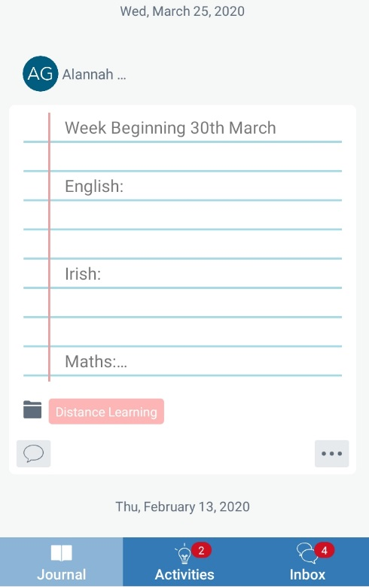

The Activities Section:
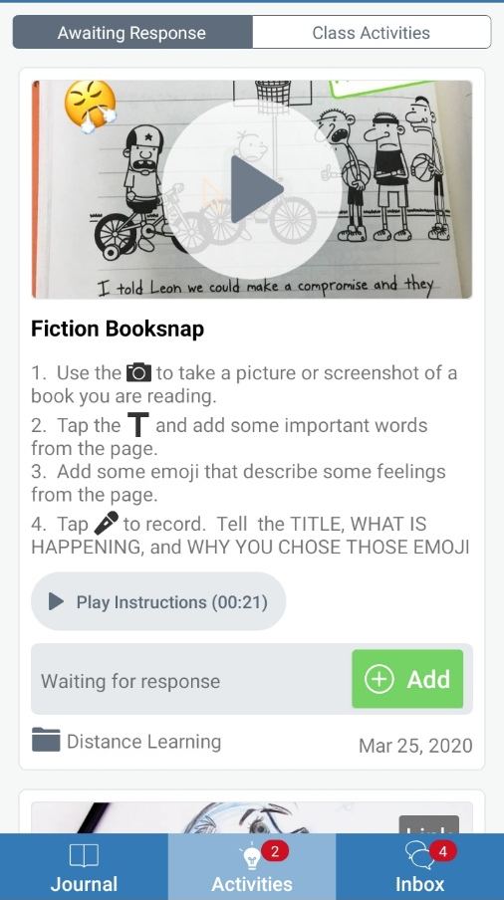

The Inbox Section:

How to Complete an Activity
Step 1:
- Click on Activity. The activity that your teacher has set for you will appear here.

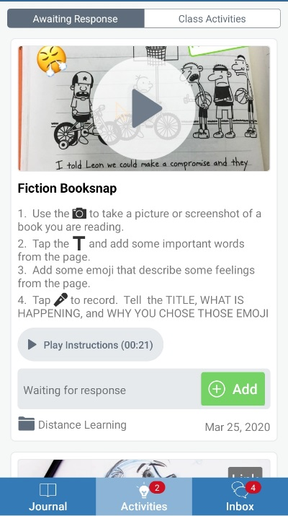
Step 2:
- Select Add. Clicking this button will let you respond to the work your teacher has set for you.
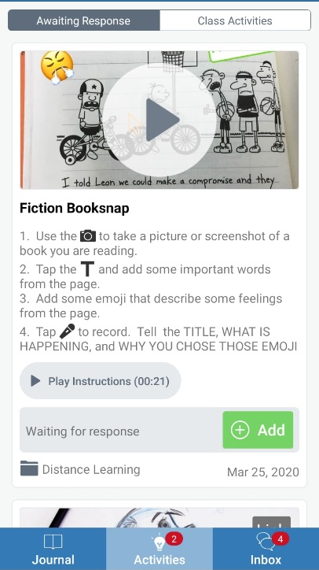

Step 3:
- Select the tool you wish to use in order to respond to the task set by your teacher.
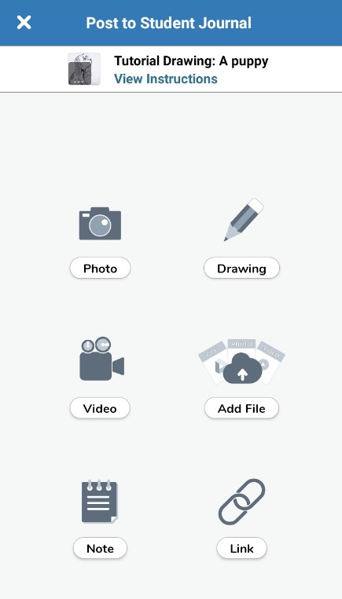
Step 4:
- In the example shown, I chose to use the photograph tool. Now that I have taken my photograph, I will now press the green tick, located at the top right corner of the screen. My work will automatically upload to my profile for my teacher to see.
