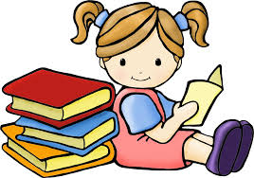
Reading Fluency
Parent’s Handout
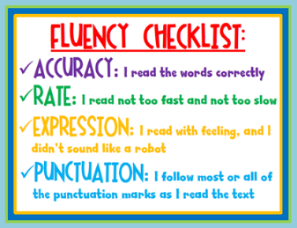
What is Reading Fluency?
Reading fluency is the ability to read a text easily.
Reading fluency has four parts: accuracy, speed, expression
and comprehension.

How to help develop your child’s reading fluency at home:
- Reading and re-reading easy books is a great way to build your child’s reading fluency.
- Model fluent reading for your child by reading aloud daily. Be sure to use expression in your reading and to pause between sentences and phrases.
- Echo reading –reading aloud and having your child match her voice to yours.
- Have your child practise reading a simple book to share with a younger child.
- Poetry and nursery rhymes can be used to practise phrasing and improve fluency.
- Set aside reading practice time every day.

Links & Online Resources
- Further Tips on: http://www.readingrockets.org/helping/target/fluency
- Use the Learning Zone on www.stbrigid.ie for websites with online books to practice fluency.
- Reading Apps: Istorybooks; Readme Stories, Tabtale App, MeeGenius

(These tips were adapted from: Eilish-Piper L. (2010) Information and Ideas for Parents about fluency and vocabulary., Illnois Reading Council Journal 38(2) 48-49)

