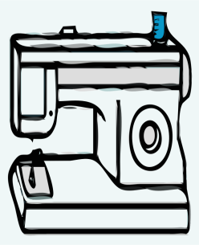
Sewing Club
A new sewing club will begin here in school for all those who want to learn how to use their sewing machines. Once you’ve learned how to use your machine you will have a chance to complete at least one project- make a cushion cover, a drawstring bag or a book bag (or all three if you get the hang of it quickly!)
The club will begin on Thursday September 15th and will be on every second Thursday from 2.30-4pm in Room 5. I will text parents the day before to remind them that the club is on. Places are limited to 8 students. Below is a list of supplies that will be needed (not needed for the first day- I have plenty fabric to practise on.)
Sewing machine- bring your manual with you too. Machines can be left in school.
Fabric: Choose something you really like because you’ll be looking at it a lot! Go for medium weight fabric – like what is used for curtains. Pick something with a small to medium size print. You can buy lovely fabric quite cheap in Ikea or try the remnants basket in Hickeys. One metre of fabric should be enough to do all three projects
Thread- to match your fabric
Scissors- must be brand new, never used on paper. The ikea pack of 3 scissors in the kitchen department is perfect.
Cushion inner (Ikea is cheapest for these)

The cost for the 7 weeks of classes up until Christmas is €50.
Hope to see you there!
Imelda O’Reilly
________________________________________________________________
My daughter ___________________from Room___ would like to join the sewing club. I agree that she may use a hot iron at the club and I undertake to practise ironing at home with her (this could be good for you )
I enclose the fee of €50.
Signed _______________________

