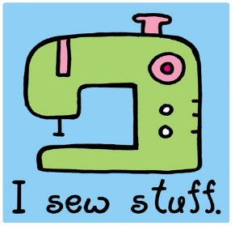

Sewing Club 2017
The St Brigid’s Sewing Club is open to new members from 5th and 6th classes. The lessons are to teach you how to use your sewing machine. You will learn how to thread your machine and bobbin and will do at least one sewing project. Each class can have a strict maximum of eight children. Classes will be every second Thursday and will start on Thursday September 14^{th.} There will be 7 classes before Christmas. Classes will finish at 4pm. After Christmas a new group of eight children can come to Sewing Club.
You will need a sewing machine and its manual, thread and brand new scissors- Ikea sell a set of 3 scissors for about €1 and these are perfect. DO NOT USE THEM TO CUT PAPER. I have plenty fabric for you to use and all other materials needed but if you want to use your own fabric for a project, one metre is plenty.
The classes cost €50 for the 7 classes.
Ms O’Reilly

Sewing Club will be in Room 5 and the girls can be collected from there at 4pm. Please let me know if you are allowing her to walk out to the gate alone. I’ll be staying in the classroom to tidy up so won’t be walking to the gate.
I give my daughter ___________________ permission to go to sewing club.
I am happy for her to be allowed to use an iron. Yes/No
My daughter can walk to the gate alone. Yes/ No
My daughter will be collected from the classroom. Yes / No
Signed ____________________ Phone __________________

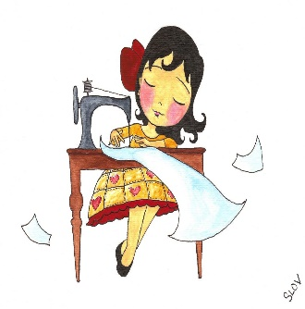
Dear Sewing Club member,
I really want you to get the most out of doing these sewing lessons. Like everything, the more you put into it, the more benefit you will get from it. If you can cut straight and sew straight, you can make anything. Sounds easy? It is, it just takes practice. So while you are waiting for your sewing classes to start, there are things that you can start doing already.
Get out your manual and find where it shows you how to thread your machine. See can you follow the instructions step by step. Even if you can’t figure out how to thread the machine, practise practise practise threading the actual needle. I WILL NOT DO THIS FOR ANYONE. The more you do it, the easier it gets. I repeat, I WILL NOT DO THIS FOR ANYONE!
Ask an adult to show you how to use the iron safely. Sewing and ironing go hand in hand so it’s really important you learn how to use the iron without burning yourself. Ironing pillowcases is a great way to practise.
If there is a project you would really like to be able to do, print it out and bring it to me to see if we can make it happen. Be realistic, you won’t be making clothes yet! Pinterest (under adult supervision, there’s some really weird stuff on Pinterest!) is a great place for inspiration. Search for ‘Easy sewing projects’ etc. and see if there’s a project that interests you. I have some projects ready for you if you can’t find inspiration.
See you soon!
Ms O’Reilly

