A Framework for Social, Personal and Health Education

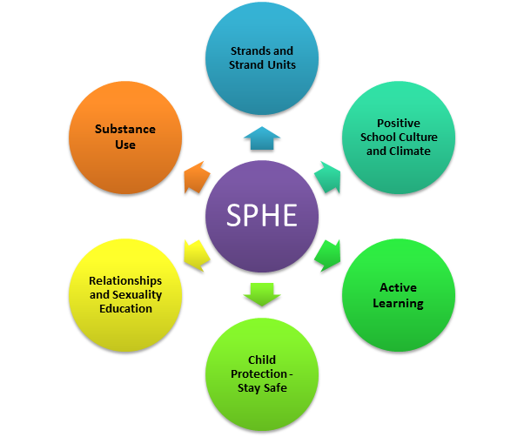

Note 1: The content of the SPHE curriculum is organised into strands/strand units as listed below.
Contexts for teaching SPHE
- Creation of a Positive School Culture and Climate
- Discrete teaching through the 3 Strands (Myself, Myself and Others, Myself and the Wider World) and associated strand units listed below
- Integration with other subjects
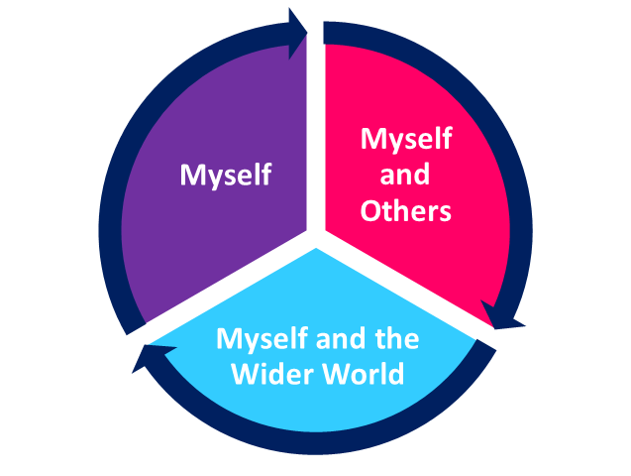
Myself  Self -identity  - Self-awareness  - Developing self-confidence  - Making decisions  Taking care of my body  - Health and well-being  - Knowing about my body  - Food and nutrition  Growing and changing  - As I grow I change  - New life  - Feelings and emotions  Safety and protection  - Personal safety  - Safety issues  Making decisions |  | Myself and Others  Myself and my family  My friends and other people  Relating to others
Myself and the Wider Wold

Developing citizenship
- My school community
- Living in the local community
- National, European and wider communities
- Environmental care
Media Education

Discrete teaching in SPHE is done via three main programmes:
- The Stay Safe Programme - a personal safety skills programme designed for use with primary school children from Junior Infants through to 6th class. The programme seeks to enhance children’s self-protective skills by participation in lessons on safe and unsafe situations, bullying, inappropriate touch, secrets, telling and stranger danger.

- The Walk Tall Programme – a substance misuse prevention programme for Junior Infants to Sixth designed to help pupils to develop appropriate skills, values and attitudes and to give them age appropriate information needed to make informed, healthy choices about substances.

- Relationships and Sexuality Education Programme - which provides structured opportunities for pupils (from Junior Infants to Sixth Class) to acquire knowledge and understanding of human sexuality and relationships through processes, which will enable them to form values and establish behaviours within a moral, spiritual and social framework.

Note 1: The Stay Safe /Walk Tall Programmes are currently being revised. It is hoped that all schools will receive copies of the new manuals during early 2017.
Note 2: During Term 3 parents will be advised of the terminology/content of the RSE programme in advance of rollout to all classes.

To ensure that each pupil receives a comprehensive programme in all strands, the school applies the following termly timetable, over a two -year cycle.

 | Even Years (Year 1)  September 2016/2018 | Odd Years (Year 2)  September 2017/2019
Term one | Myself: Self Identity/My Friends  September/October | Myself and Others: Relating to Others  September/October
 | Myself and Others: My Friends & Other People  November/December | Myself and Others: Myself and my Family  November/December
Term two  Stay Safe Programme | Myself: Safety and Protection to incorporate Media Education (Myself and the Wider World)  January/February | Myself: Safety and Protection to incorporate Media Education (Myself and the Wider World)  January/February
 | Myself: Taking Care of My Body  Myself and the Wider World: Developing Citizenship  March/April | Myself: Taking Care of my Body  Myself and the Wider World: Developing Citizenship  March/April
Term three  (Relationships & Sexuality) | Myself: Growing & Changing  May/June | Myself: Making Decisions (3rd to 6th Class)  May/June  Junior Classes: Road/Fire/Water Safety (Junior Infants to 2nd)

