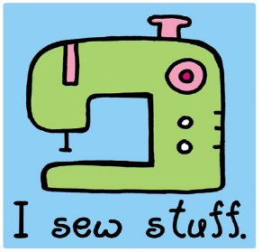

Sewing Club
The St Brigid’s Sewing Club is open to new members from 5th and 6th classes. Classes will be taught in 4 week blocks with a maximum of 8 girls in the class. The girls will learn a little bit of hand sewing and a little bit of machine sewing while making a sewing project. It is not necessary to have a sewing machine.
Ms O’Reilly will take names of children interested in Sewing Club and if there are more than 8 interested, she will pull out names from a hat. Classes are held on Thursdays from 2.30 to 4pm.
The next block of lessons will be on the following dates:
Jan 24th; Jan 31st; Feb 7th; Feb 14th
The cost is €20 and this covers all materials used.

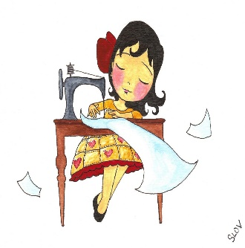
Dear Sewing Club member,
I really want you to get the most out of doing these sewing lessons. Like everything, the more you put into it, the more benefit you will get from it. If you can cut straight and sew straight, you can make anything. Sounds easy? It is, it just takes practice. So while you are waiting for your sewing classes to start, there are things that you can start doing already.
Learn to thread a needle. I won’t help you thread needles- I could spend the whole class threading needles! If there is an adult in your house who can hand sew, ask them to show you how to sew- it really isn’t difficult.
If you have a sewing machine, get out your manual and find where it shows you how to thread your machine. See can you follow the instructions step by step. Even if you can’t figure out how to thread the machine, practise practise practise threading the actual needle. I WILL NOT DO THIS FOR ANYONE. The more you do it, the easier it gets. I repeat, I WILL NOT DO THIS FOR ANYONE!
Ask an adult to show you how to use the iron safely. Sewing and ironing go hand in hand so it’s really important you learn how to use the iron without burning yourself. Ironing pillowcases is a great way to practise.
I will have a project ready for you when you start your class.
See you soon!
Ms O’Reilly

